**Lab 7: Scale and Load Balance your Architecture**

Paul Polsinelli

Information Technology, Arizona State University

IFT 472: Managing the Cloud

Professor Neff

Sep 20th, 2020

**Lab 7: Scale and Load Balance your Architecture**

**Figure 1**

*A screenshot of the auto scaling group page.*

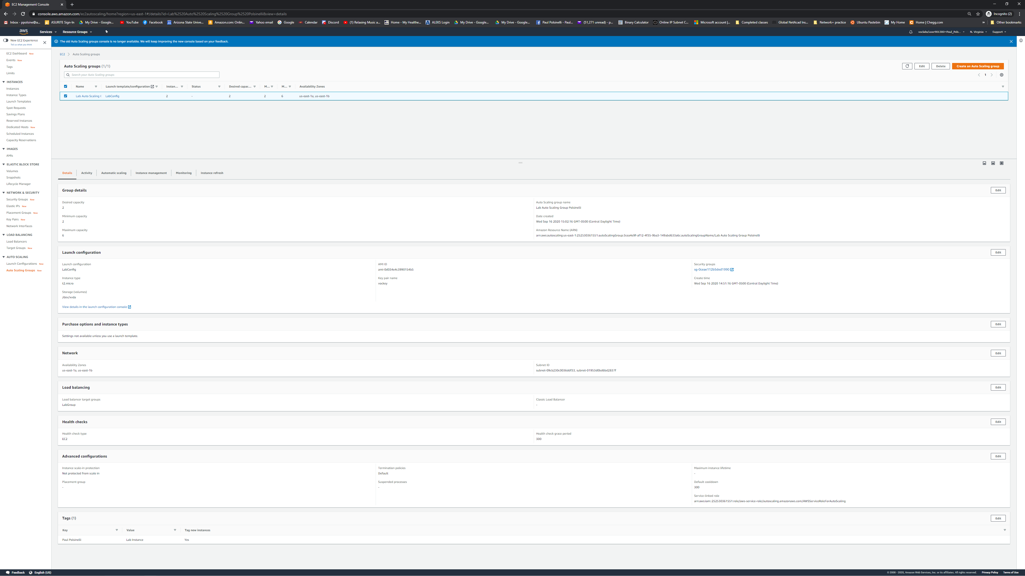

**Figure 2**

*A screenshot of the Load Balancers page.*

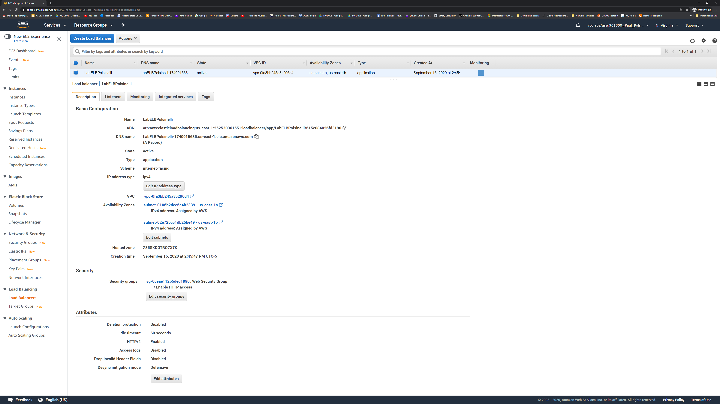

**Figure 3**

*A screenshot of browser hitting website.*

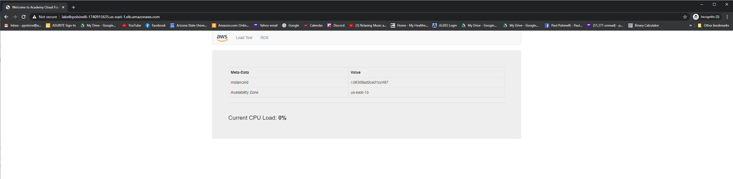

**Figure 4**

*A screenshot of instances page.*

